TP MODUL 10

Nama: Zhafir Zaidan Avail

NIM: 2311104059

Hasil Output:

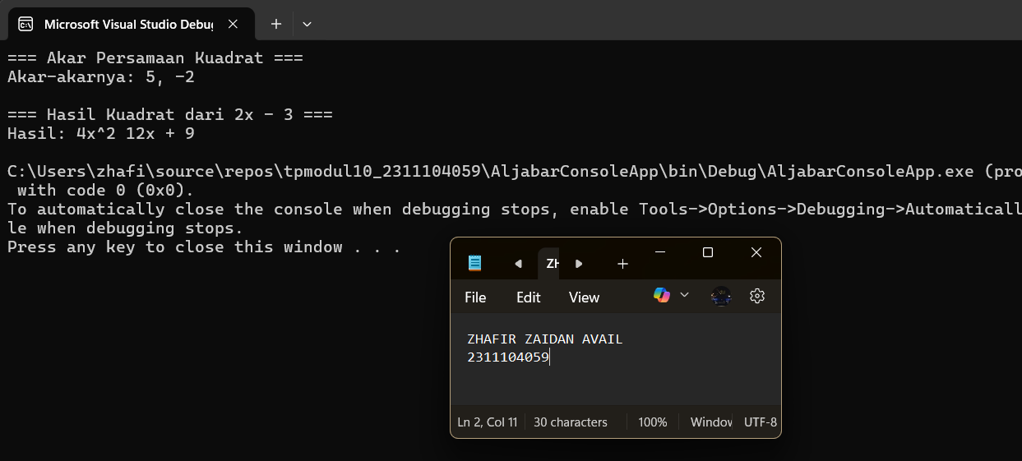

1. Project Class Library AljabarLibraries

Kode Aljabar.cs:

using System;

namespace AljabarLibraries

{

public class Aljabar

{

public static double[] AkarPersamaanKuadrat(double[] persamaan)

{

double a = persamaan[0];

double b = persamaan[1];

double c = persamaan[2];

double D = b \* b - 4 \* a \* c;

if (D < 0) return new double[] { }; // tidak punya akar real

double akar1 = (-b + Math.Sqrt(D)) / (2 \* a);

double akar2 = (-b - Math.Sqrt(D)) / (2 \* a);

return new double[] { akar1, akar2 };

}

public static double[] HasilKuadrat(double[] persamaan)

{

double a = persamaan[0];

double b = persamaan[1];

double A = a \* a;

double B = 2 \* a \* b;

double C = b \* b;

return new double[] { A, -B, C }; // -B karena rumus (a - b)^2

}

}

}

1. Console App untuk Memanggil Library

Kode di Program.cs:

using System;

using AljabarLibraries;

class Program

{

static void Main(string[] args)

{

Console.WriteLine("=== Akar Persamaan Kuadrat ===");

double[] akar = Aljabar.AkarPersamaanKuadrat(new double[] { 1, -3, -10 });

Console.WriteLine($"Akar-akarnya: {string.Join(", ", akar)}");

Console.WriteLine("\n=== Hasil Kuadrat dari 2x - 3 ===");

double[] kuadrat = Aljabar.HasilKuadrat(new double[] { 2, -3 });

Console.WriteLine($"Hasil: {kuadrat[0]}x^2 {kuadrat[1]}x + {kuadrat[2]}");

}

}